Environment configuration
Python 3.11.7
python -m venv venv
venv\Scripts\activate
There is an extra (venv) in front of the command line, indicating that the environment has been activated. Run the following in the activated state:
pip install numpy pandas scikit-learn matplotlib scipy tqdm streamlit
Everything is normal. It should display:
Successfully installed numpy pandas scikit-learn matplotlib scipy tqdm streamlit …
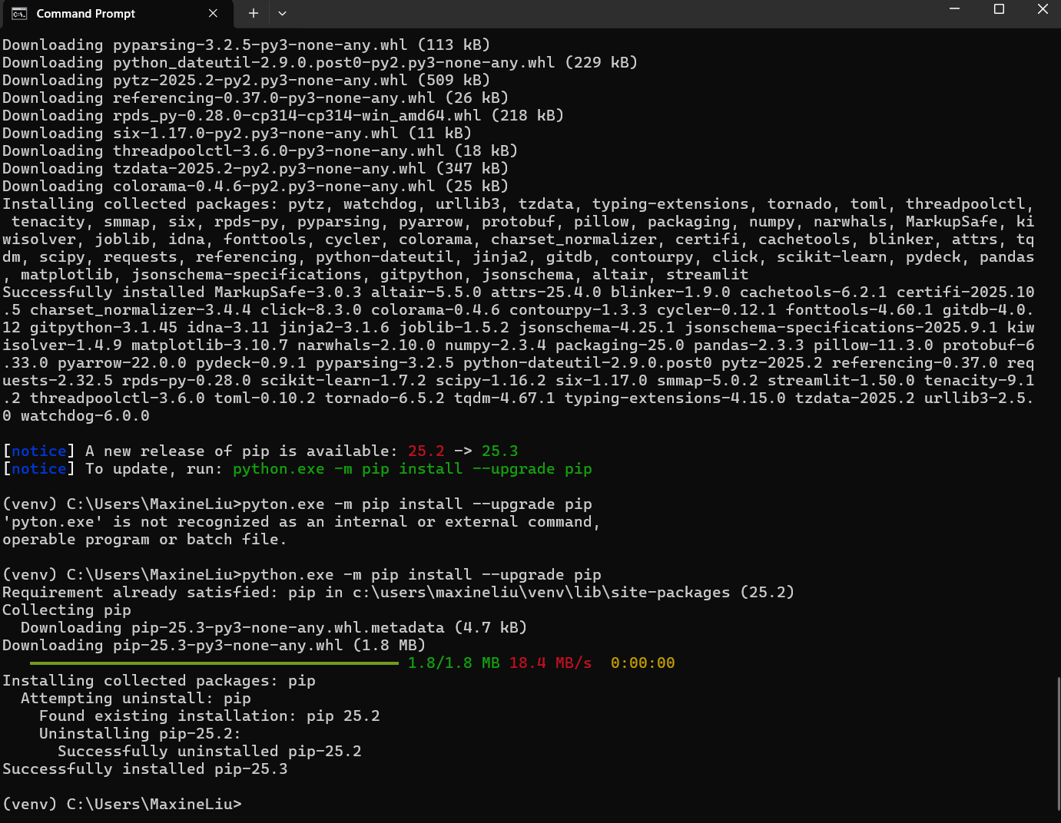
Dependence
Pip install shap tensorflow-cpu

New:
https://www.python.org/ftp/python/3.10.11/python-3.10.11-amd64.exe
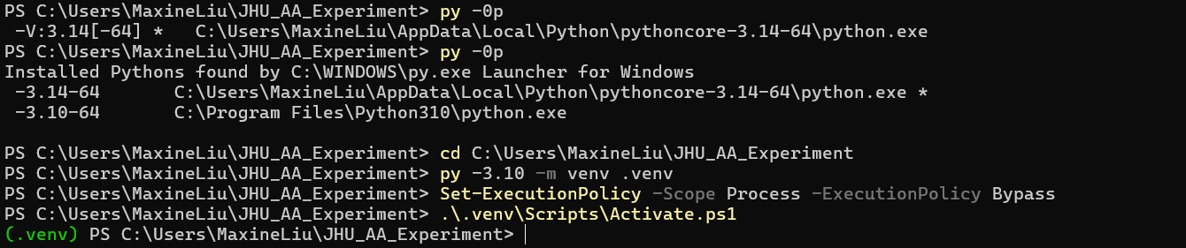
Copy and paste the following command in the current window (while keeping it in (.venv) state):
python -m pip install -U pip wheel
pip install numpy pandas scikit-learn matplotlib scipy tqdm shap tensorflow-cpu==2.15.0
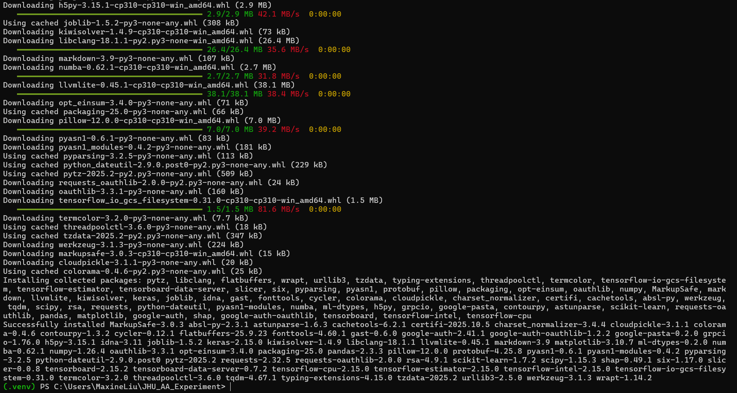
If this last command results in an error (some machines will display "no matching distribution" message),
then use this alternative command instead.：
pip install tensorflow==2.15.0

Run:
In the venv environment:
cd c:\Users\maxineliu\JHU_AA_Experiment
python experiment.py

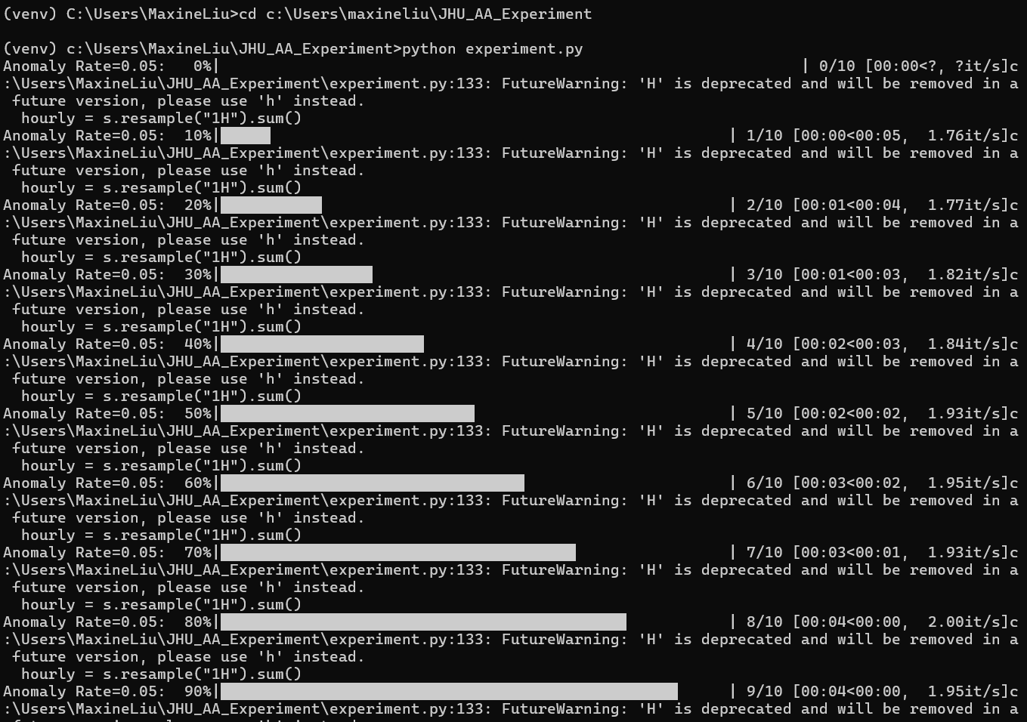

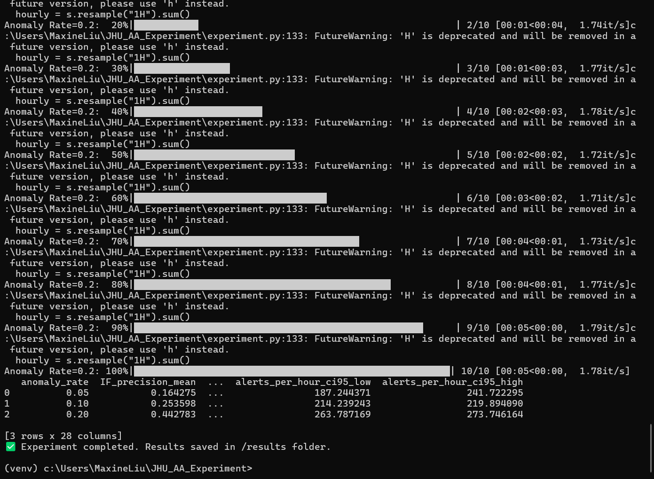

Data download link
311 Service Requests from 2010 to Present | NYC Open Data

